groundWater Investigation USING RESISTIVITY METHOD and Drilling for Drought Mitigation in Tulungagung, Indonesia
International Journal of GEOMATE, July, 2018 Vol.15, Issue 47, pp.124-131
Geotec., Const. Mat. & Env., DOI: https://doi.org/10.21660/2018.47.98784
ISSN: 2186-2982 (Print), 2186-2990 (Online), Japan

*Adi Susilo¹, Sunaryo¹ and Fina Fitriah¹
¹Geophysical Engineering, Brawijaya University, Indonesia
*Corresponding Author, Received: 31 Dec. 2017, Revised: 12 Jan 2018, Accepted: 12 Feb. 2018

ABSTRACT: Research of the groundwater in Pakel, Bandung and Besuki Subdistricts, Tulungagung District has been implemented. The research area is located in the rice field area, previously an area of annual flooding inundation during the rainy season. This situation troubles the community and local government of Tulungagung District. During the dry season, the mud cracks, making it difficult as agricultural land. The research was done using Geoelectrical Resistivity Schlumberger configuration method. The measurement point is located in the three Subdistricts with a total of 19 measurement points. The study location is at 111.7598888⁰ EL; -8.226416667⁰ SL to111.8454167⁰ EL; 8.130916666⁰ SL or covers an area of 101 km². The length of the track used is a maximum of 600 meters. Based on the results of the geoelectrical resistivity data, it was found two types of aquifers, which are open aquifers in depth ranging from 6 m to 21 m and a confined aquifer in depth ranging from 90 to 115 m. In addition to the geoelectrical information data, drilling was done at an accessible point by heavy equipment in the Gempolan Village, Pakel Subdistrict. At the drilling point, artesian wells were obtained at a depth of 108 meters and can rise to 2 meters above the soil surface. The discovery of artesian wells is then used by residents to meet the needs of clean water considering that in this area most wells are smell and iron contain.

Keywords: Geoelectrical, Schlumberger, Artesian, Tulungagung

INTRODUCTION

In the past, the rice fields in Tulungagung District were flooded areas, troubling the people and the government of Tulungagung District. When there is no flooding, it has fertile soil, reliable for agriculture (rice supplier) in Tulungagung District. In the 80s or 90s “Parit Agung” channels, “Neyama” Tunnel and water channels were created to ensure a flood free region. The concept of development of the Parit Agung uses the concept of drainage. This raises the problem as during the dry season the rice fields do not get water supply, making the land use unable to be used. This has an impact on the occurrence of failed harvest and drought in the region. It is possible that this area is also a swamp area, so in the dry season, there will be mud crack at the top of the land. Also, the iron content of water in the area is quite high in the resident wells.
According to data from Tulungagung Regional development planning agency, drought in Tulungagung District is spread in three Subdistricts, which are Pakel, Bandung, and Besuki. The drought area in these three Subdistricts varies from 1-56 ha with moderate drought to failed harvest. The high number of drought makes it necessary to research groundwater in the location as a solution for the drought in the dry season and the supply of clean water for the citizens.
One method that can be used for groundwater investigation without going through direct drilling is the geophysical method. This method uses physical parameters to obtain the subsurface condition of an area. The geophysical method used in this case is the geoelectrical resistivity method. The resistivity method uses physical parameters in the form of resistivity of subsurface rock types. In principle, a current is injected through two current electrodes, and then a potential difference is measured through the two potential electrodes [1-3]. Resistivity surveys have been used for decades in hydrogeology to detect water or aquifer layers, mining or mineral investigations, and geotechnical to know the subsurface structure, even now it is also used for environmental surveys to detect environmental pollution [4-8]. There has been much research on groundwater investigations using geoelectrical methods [9-16]. These studies show a good correlation to geoelectrical methods in groundwater investigations. Therefore, the result of geoelectrical data interpretation is expected to give an overview of the subsurface condition of the research location and be able to give pictures of the location that allows groundwater to be drilled. Thus, it able to overcome the problem of water drought in the research location.

FIELD STUDY

The research location is located in the western part of Tulunagung District at Pakel, Bandung, and Besuki Subdistricts. Geologically, this area is in the geology of Southern Tulungagung District which is a hilly area with a height of about 175 m to 900 m above ground level. Physiographically, this area is the Southern Mountain line that stretches from Jogjakarta, Central Java and East Java, where there are various rock outcrops from Oligo-Miocene to Pliocene.
The local geology of the research area (Subdistricts of Bandung, Pakel, and Besuki) is an alluvial area. Historically, this area is a fault block that descends from the subduction zone where the oceanic plates in the southern island of Java subduct the continental plates on a small scale in the southern part of Java Island. The study area is included in the descending block. The downside block part of this shape can be like a bowl, where the center will have a deeper position than the edges. Or it could be said that the part that is still close to the downside block area will have a relatively higher surface compared with the middle. So this area is a basin, with bedrock properties that can hold/preserve water. By the principle of geology, these basins will be filled by erosion sediments, which in the settling process will fill the lowest area first, i.e., the middle, with a horizontal direction, then rise increasingly with the increasing number of incoming sediments. This sediment will continue until there can no longer be a sedimentation process.
In earlier times, this area was a swamp area, which during the rainy season, it was water reservoir area. Since it is a swamp area, the topsoil is smoother than the lower part. With the construction of a drainage area during the Japanese occupation, this area could be slightly free from flooding and begin to be inhabited by the inhabitants. As it is previously a swamp area, in the future it can be used as a rice field area, as a result, during the rainy season, the water will be abundant, but during the long dry season, the topsoil of the rice fields mud crack occurs. With such circumstances, the area which during the rainy season can be used for rice crops, etc., during the dry season, it is less able to function for agriculture. As it is a former swamp area, it is possible that upper groundwater (free aquifer) will have acidic taste and smell, because it is a direct infiltration of the rainwater accommodated. While the lower part of groundwater in the area that is confined aquifer, where the recharge is not direct rainwater from the upper part of the layer (it is possible the recharge is from Mount Wilis and the higher areas around it), it will have a better taste and smell [17].

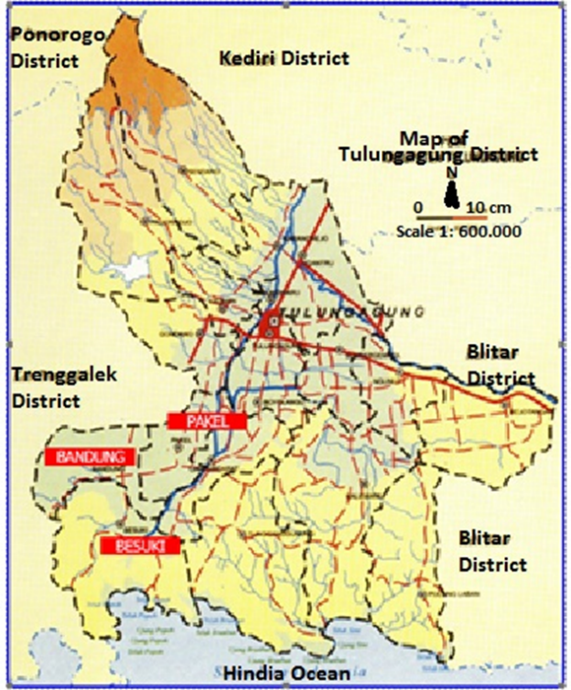
Fig 1. Map of Tulungagung District

- THEORETICAL BACKGROUND

Geophysics is a part of the geoscience group that uses physical parameters to determine the condition of the subsurface through measurements made on the earth's surface, both active and passive measurements. One of the physical parameters is the earth's electrical properties, popular with the term geoelectrical method. This method detects subsurface conditions based on contrasting electrical properties of the earth's constituent rocks. One of the geoelectrical methods is the geoelectric resistivity method. Geoelectric resistivity surveys have been used for decades, in hydrogeology for the determination of the aquifer, mineral investigations, geotechnics, structural geology (fault), and the determination of archaeological traces [2-7]
The configuration used in the geoelectric resistivity survey has many options, one of which is the Wenner-Schlumberger configuration. This configuration is the right choice for the depth target(sounding) or commonly known as Vertical Electrical Sounding (VES). This is due to field effectiveness and reduction of accumulation error. This configuration is the result of the modification of Schlumberger configuration referring to Indonesian National Standard (SNI) for groundwater exploration method, that is SNI 03-2818-1992 with Wenner configuration. The configuration of the Wenner-Schlumberger configuration is as follows:

Fig. 2. Wenner-Schlumberger Configuration [1]

C1 and C2 are current electrodes while P1 and P2 are potential electrodes. The geometry factor for the configuration is
$$k=π n \left(n+1\right)a$$
Thus the apparent resistivity of the Wenner Schlumberger configuration can be written as follows:
$$ρ_{a}=π n \left(n+1\right)a \frac{∆V}{I}$$
With $ρ_{a}$ is the apparent resistivity $(Ω.m)$, $a$ is the spacing of the electrode (m), $n$ is the discrete number, $∆V$ is the potential difference (V) and $I$ is the current (A) [1].

- METHOD

Data acquisition has been conducted in Pakel Subdistricts (covering 11 villages: Duwet, Sodo, Ngebong, Bangun Mulyo, Kasreman, Ngrance, Sanan, Bangun Jaya, Bono, Suko Anyar and Sambitan), Bandung Subdistrict (covering 4 villages: Bantengan, Suruhan Kidul, Singgit, and Ngunggahan), and Besuki Subdistrict (covering 4 villages: Suwaru, Kundung Embankment, Besuki, and Besole), at Tulungagung District of East Java. Surveys are conducted on the location using UTM coordinate: (111.75988880; -8.2264166670) to (111.84541670; -8.1309166660) or covers an area of 101km². Each village is represented by one sounding point of Vertical Electrical Sounding (VES). The configuration of the Resistivity method was the Schlumberger configuration, both current and potential were arranged in such a way as to obtain a target depth between 100 m up to 200 m. The path length of each maximum point is 600 m. The number of sounding points was 19 VES with the distribution as in Fig. 3.

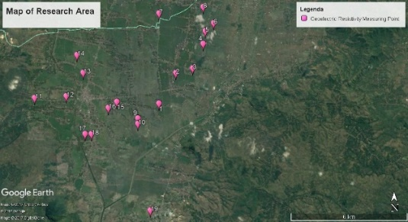

Fig. 3. 19 VES sounding point in Pakel, Bandung and Besuki Subdistricts, Tulungagung District

The resistivity study or survey in the Pakel, Bandung, and Besuki Subdistricts used a Wenner-Schlumberger configuration with a fixed potential electrode and electrode currents running to get a depth variation direction (sounding). To obtain the lateral variation, it was connected to each VES sounding points through the interpolation process. The use of the Wenner-Schlumberger configuration is the most appropriate choice for Vertical Electrical Sounding (VES) targets for field effectiveness and accumulation error reduction. As mentioned in the theoretical background that this configuration is the result of the modification of Schlumberger configuration referring to Indonesian National Standard (SNI) for groundwater exploration method, that is SNI number 03-2818-1992 with Wenner configuration. Data processing was done using Progress software (fitting curve automatic forward and inversion) and Surfer 13 (plot of resistivity distribution at each specified depth). The results of data processing can obtain information of possible aquifers distribution in the subsurface which will then be used as a reference for drilling points around the study site.

- RESULT AND DISCUSSION

Based on the results of data processing, it is obtained the resistivity distribution at each depth (Figure 4) by using Surfer 13 software. Interpolation of resistivity contours to a depth of 10-115 meters is done with a difference of 15 meters to know a more specific contour change when it is compared to resistivity contour of low, medium and high. If a more specific contour change picture is given then easier interpretation can be made.
Figure 4, from 4a to 4h are the figures of a layer based on resistivity value for every depth. These Figures explain that the low resistivity indicates the depth that has high conductivity. Because this area used to be swamp area, so the sediment compiler should be terrigenous sediment. Therefore, the low resistivity may/should represent the aquifer. Resistivity range can be divided into three parts, i.e., resistivity between 0-200 Ωm (gravel and sands), 200-800 Ωm (alluvium) and> 800 Ωm (sandstone).
Based on the results of the interpretation, there are some open aquifers at the sounding point of VES Sanan, Bangun Jaya, Bono, Ngunggahan, Tanggalkundung, and Besuki villages with a depth ranging from 6-21 meters below the surface. Also, the existence of a confined aquifer at the point VES of Sanan, Bono, Singgit, Nngunggahan, and Tanggulkundung villages with a depth of 90-115 meters is also seen.
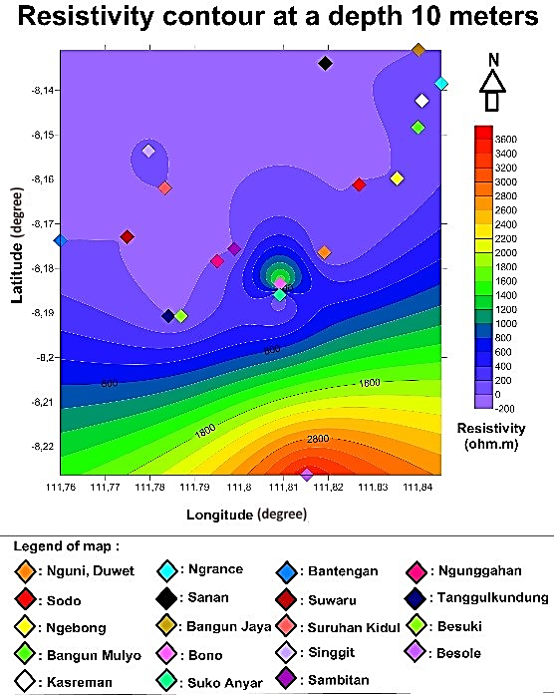

Fig. 4a. Resistivity contour at a depth of 10 meters. The unconfined aquifer was in Bono and Besole villages.

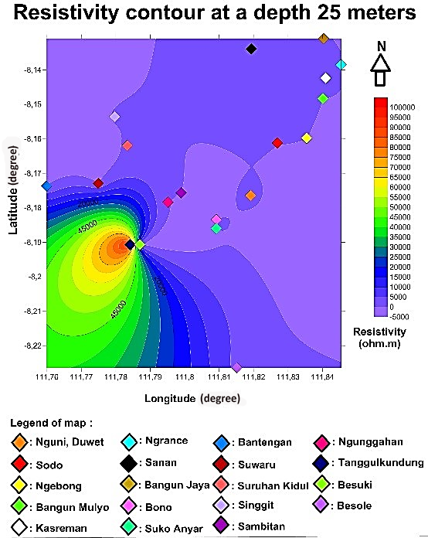

Fig. 4b. Resistivity contour at a depth of 25 meters.
The indication of unconfined aquifer was in Bangun Jaya, Ngunggahan, Tanggulkundung and Sanan villages
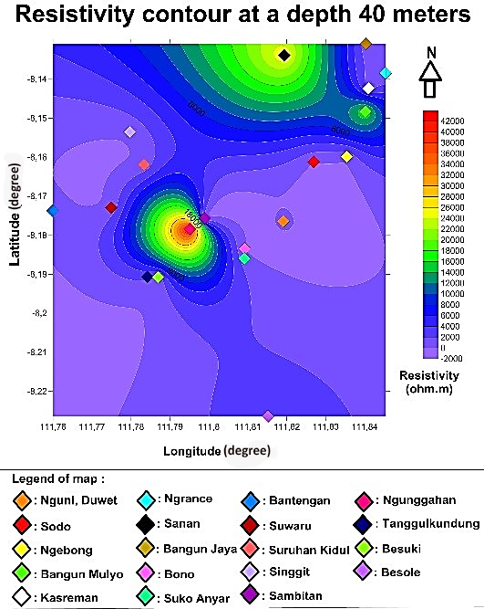

Fig. 4c. Resistivity contour at a depth of 40 meters. Most of VES is unconfined aquifer.

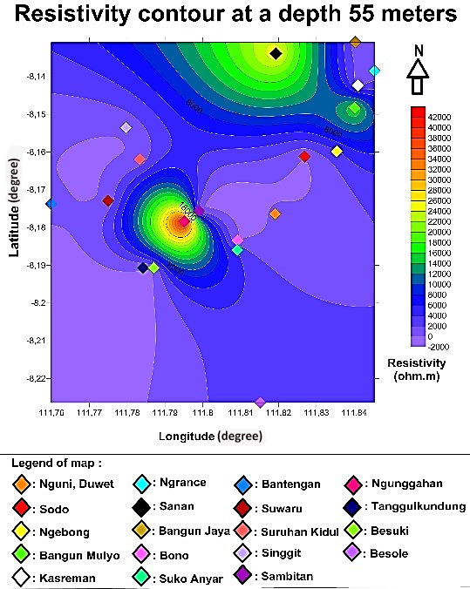

Fig. 4d. Resistivity contour at a depth of 55 meters. Most of the VES is unconfined aquifer.

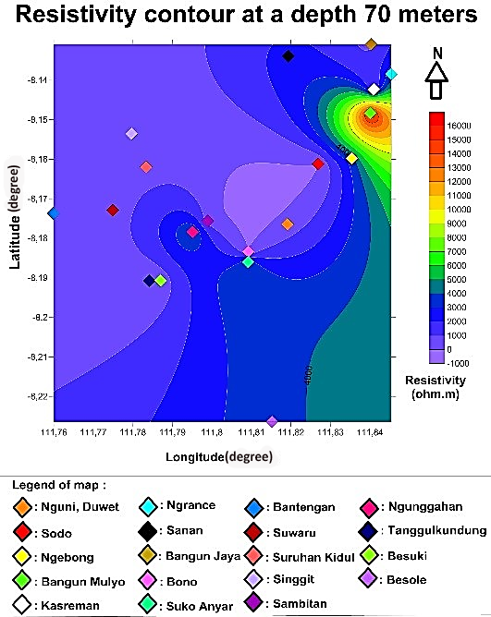

Fig. 4e. Resistivity contour at a depth of 70 meters.

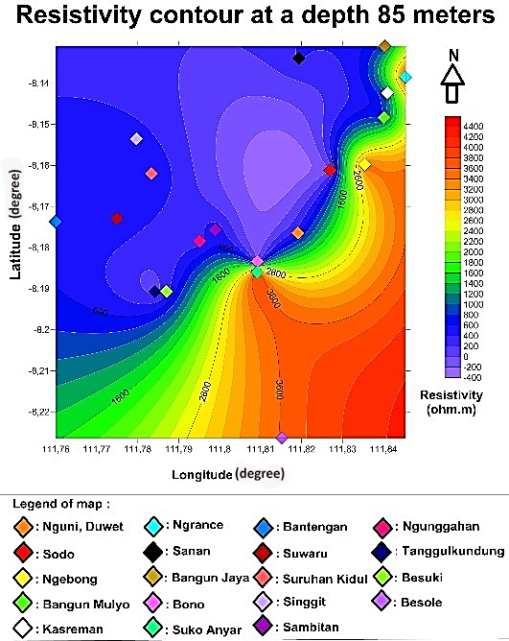

Fig. 4f. Resistivity contour at a depth of 85 meters.

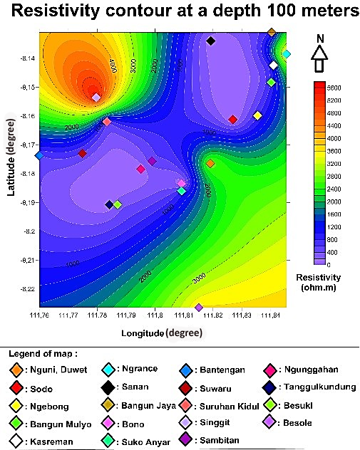

Fig. 4g. Resistivity contour at a depth of 100 meters. The indication of the confined aquifer was in Tanggulkundung, Sanan and Ngunggahan villages.

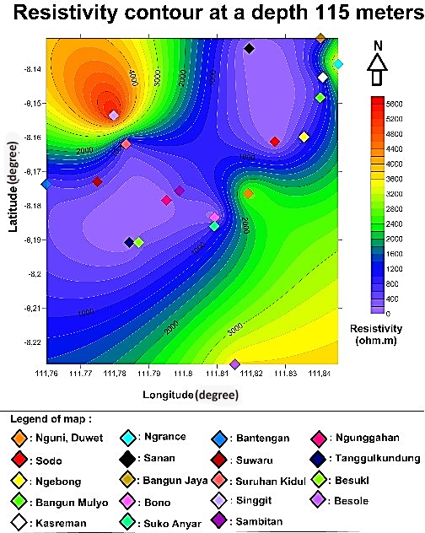

Fig. 4h. Resistivity contour at a depth of 115 meters. Confined aquifer was still at Tanggulkundung, Sanan, and Ngunggahan Villages.
Considering the location that can be reached by drilling tools and access roads that can be passed and nearby location with the settlement of citizens, drilling is conducted in the village of Gempolan, Pakel Subdistrict at coordinates 8.111672 SL and 111.843881 EL, in front of Darussabilillah mosque. At a depth of about 108 meters from the surface, artesian water occurs, as seen in Figure 5.
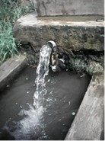 | 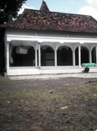
a b
Fig. 5. (a) Drilling artesian wells and (b) Darussabilillah Mosque north of the artesian wells

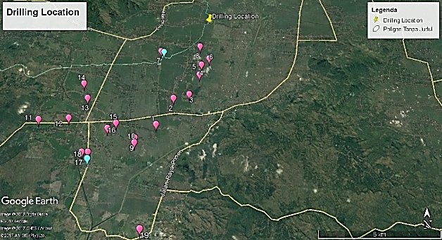

Fig. 6. Drilling Location. Yellow pin is the drilling location, and two blue balloons are the recommendation of drilling wells.

Figure 6 shows locations of the resistivity measurement (red balloons), artesian well (yellow pin) and recommendation of drilling wells (two blue balloons). Another drilling location should consider road access for drilling equipment (mobilization and demobilization) and its location close to the residents. Artesian water is then used by residents for the fulfillment of clean water considering the existing water in the research location is smelly and contains iron due to its former location as a swamp. The possible drilling location is depicted in Figure 6. If cross section is done for two suggested locations for further drilling in Tanggulkundung and Sanan villages, it will ease the estimation of this area's recharge location. Both locations are possibly artesian as it is seen that the two locations based on the geoelectric interpretation data which are confined aquifer. Figure 7 shows that at a depth of approximately 90 meters to 115 meters at Sanan and Tanggulkundung villages, the rock resistivity ranges from 33 to 63 ohm.m. The resistivity range can be interpreted as gravel and sand. At that depth, it is also possible to be an artesian well, due to drilling at Gempolan, Pakel at a depth of fewer than 108 meters in finding artesian wells. The difference of depth is possible as the drilling at Gempolan is through direct drilling at a depth of about 108 meters, but the location of the artesian wells could start at a depth of about 90 meters. Here is a cross-section of the 2D cross-section for the drilling point and two points suggested for drilling:
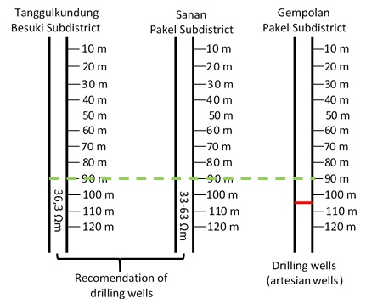

Fig. 7. 2D cross-section between drilling wells with two recommended locations for drilling

The water found near the place of worship helps to meet the needs of clean water. There are still other potential areas for artesian groundwater. The presence of artesian water indicates that it must be a recharge for the area. An artesian recharge is a higher area of artificial artesian location and is usually a mountainous area. The map shows that the mountain which is located in the north and close to the research location is Mount Wilis which is approximately of 33 km (Figure 8).

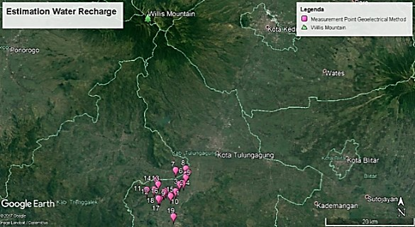

Fig. 8. Estimation Water Recharges. The blue pin, just North of the location of study is top of Wilis Mount.
These three Subdistricts are alluvial areas with varying degrees of drought, from the medium, heavy to “puso” or failed harvesting. The data from Regional Planning and Development Agencies (Bappeda) of Tulungagung District in 2004, Pakel Subdistrict (590 ha), Bandung Subdistrict (57 ha), and Besuki sub-district (23 ha) experienced drought. Every year, drought news in Tulungagung District continues to expand. The provided clean water from the village government is still not able to meet the needs of clean water of the society and rice fields when the dry season arrives.These three Subdistricts are the rice field during the rain season and cornfield during the dry season. During the dry season, people must drill the pump water for watering the corn plant. It needs at least four times to water the corn from the beginning until the harvesting of the crop, and consequently, it needs more budget to grow this crop. One of the mitigation efforts that can be done is to drill the well on the confined aquifer based on the information of this research using geoelectric resistivity method. Drilling on confined aquifer can be a source of water needed by society and rice fields as this type of aquifer tends to be stable and unaffected by the seasons.Therefore, if another well can be drilled, it can reduce the budget, especially during the dry season.

- CONCLUSION

The former location of the study was a swamp, so the sedimentation model that occurs follows the principle of horizontality. Based on the results, it can be said that between each point, the Subdistricts will have the same deposition model enabling it to be correlated to its subsurface resistivity model (contour for each desired depth). Also, based on the results of the resistivity data, it is known there are two models of the aquifer; free aquifer and confined aquifer. This is supported by the discovery of artesian water at a depth of 108 meters below the surface that can be directly consumed by residents in Gempolan Village, Pakel Subdistrict. The discovery of artesian water has provided a solution of drought and lack of groundwater in all three Districts of the study sites. Referring to the interpretation result, it is possible for a prospective location to be located in Bono and Sanan Villages, Pakel Subdistrict, Ngunggahan Village in Bandung Subdistrict and Tanggulkundung Village in Besuki Subdistrict. Recommendation for subsequent possible drilling locations is Tanggulkundung and Sanan Villages, as both locations are close to the access road and residential area.

- REFERENCES

- Loke.M.H. 2000. Electrical Imaging Surveys for Environmental and Engineering Studies: A Practical Guide to 2-D and 3-D Survey. Penang. Malaysia.
- Telford W.M., Geldart L.P., and Sheriff R.E. 1990. Applied Geophysics. Cambridge University Press. USA
- Reynolds, J.M. 1997. An Introduction to Applied and Environmental Geophysics. John Wiley & Sons. USA
- Akhter, G, and M. Hasan. 2016. Determination of aquifer parameters using geoelectrical sounding and pumping test data Khanewal District, Pakistan. Geosciences. Vol 8. Pp. 630-638. DOI 10.1515/geo-2016-0071
- Susilo, A., Sunaryo, and Fina Fitriah. Fault Identification For Human Settlement in Pohgajih Village, Blitar, Indonesia Using Geoelectrical Resistivity Method for Hazard Mitigation. International Journal of Geomate. Vol.14, 2018, pp 111-118
- Susilo, A., Sunaryo, Kosmas I., Rusli. Investigation of Jabung Temple Subsurface at Probolinggo, Indonesia using Resistivity and Geomagnetic Method. International Journal of Geomate. Vol. 13, 2017, pp 74-80
- Susilo, A., Sunaryo, Alexander T. Sutanhaji, Fina Fitriah and M.F.R Hasan.2017. Identification of Underground River Flow in Karst Area Using Geoelectric and Self-Potential Methods in Druju Region, Southern Malang, Indonesia, International Journal of Applied Engineering Research, Volume 12, Number 12. Pp 10731-10738.
- Mohammaden, M.I.I. 2016. Delineating Groundwater Aquifer and Subsurface Structures by Using Geoelectrical Data: Case Study (Dakhla Oasis, Egypt). NRIAG Journal of Astronomy and Geophysics. Vol. 5. Pp. 247-253
- Sajeena.S., Abdul Hakim V.M., and Kurien E.K. 2014. Identification of Groundwater Prospective Zones Using Geoelectrical and Electromagnetics Surveys. International Journal of Engineering Inventions. Vol. 3. No. 6. pp. 17-21
- Darsono, B.Legowo, and S. Koesuma. 2016. Identification of aquifer potential by using resistivity method: A case study in Kedawung and Sambirejo District, Sragen, Central Java, Indonesia. Journal of Physics. Vol. 776. Pp 1-6. doi:10.1088/1742-6596/776/1/012121
- Selvam, S.and Sivasubramanian, P. 2012. Groundwater potential zone identification using geoelectrical survey A case study from Medak District, Andhra Pradesh, India. International Journal of Geomatics and Geosciences. Vol. 3 No.1. pp 55-62
- Ahilan, J. and Kumar, G.R.S. 2011. Identification of aquifer zones by VES method: A case Study from Mangalore Block, Tamil Nadu, S. India. Applied Sciences Research. Vol 3. No 2. Pp 414-421.
- Keleko, T.D.A. Jean Marie T., Josep K., Tabod C.T, Alain N.S.F., and Jean-Victor K. 2013. Groundwater Investigation Using Geoelectrical Method: A Case Study of the Western Region of Cameroon. Journal of Water Resource and Protection. Vol 5. Pp 633-641. doi.org/10.4236/jwarp.2013.56064
- Sandberg, S.K., L.D. Slater., and R. Versteeg. 2002. An Integrated Geophysical Investigation of The Hydrology of An Anisotropic Unconfined Aquifer. Journal of Hydrology (Elsevier). Vol. 267. Pp.227-243.
- Mendecky, M.J., Ewa, J., Radoslaw, K., and Adam, I. The Use of Geoelectrical Method in Preliminary Investigation of The FredroFamily’s Irom Mine Adit: International Journal of Geophysics In The Village of Cisna, The Bieszczady Mountains, Se Poland, Acta Geodya Geomater 2016, 13, 159-165.
- Voytek. E.B., Caitlin R.R., Sarah, E.G., and Kamini S. 2016. Identifying Hydrological Flowpaths on Arctic Hillslopes Using Electrical Resistivity and Self Potential. Geophysics. Vol. 81. No. 1. Pp. 225-232
- Samodra, H., Suharsono, Gafoer S, dan Suwanti, T. (1992): Geological Map of Tulungagung, Java. Geological Research and Development Centre, Bandung, Indonesia.

Copyright © Int. J. of GEOMATE. All rights reserved, including the making of copies unless permission is obtained from the copyright proprietors.

